บรรณานุกรม

- H.M. Dietel, P.J. Dietel, J.P. Liperi, B.A. Wiedermann Python How To Program, Prentice Hall, Upper Saddle River, New Jersey, 2002.
- Rafael C. Gonzalez, Richard E. Woods Digital Image Processing second edition, Prentice Hall, Upper Saddle River, New Jersey, 2002.
- Guido van Rossum, Fred L. Drake Python Tutorial Release 2.4, Python Software Foundation
- จักรกฤษณ์ แสงแก้ว การเขียนโปรแกรมภาษาไพธอนด้วยตนเอง, สำนักพิมพ์ ส.ส.ท., กรุงเทพฯ, 2006
- Erwin Kreyszig Advanced Engineering Mathematics Seventh Edition, JOHN WILEY&SONS, INC., New York
- Gautam Pant, Padmini Srinivasan, Filippo Menczer “Crawling the Web”
- Liang K.M., Scott S.D., Waqas M. “Detecting Pornographic Image” , Asia Pacific Institute of Information Technology, Kuala Lumper, Malaysia .
- Feng Jiao, Wen Gao, Lijuan Duan, Guoqin Cui “Detecting Adult Image Using Multiple Features” , The Institute of Computing Technology, Beijing China, 2001.
- W.H Ho, P.A. Watters “Identifying and Blocking Pornographic Content”
- Yi Chan, Richard Harvey, Dan Smith “Building systems to block pornography”, School of Information Systems, University of East Anglia, Norwich, UK, 1999.
- Qing-Fang Zheng, Wei Zeng, Gao Wen, Wei-Quing Wang “Shape-base Adult Images Detection” , The Institute of Computing Technology, Beijing China, 2004
- Christophe Garcia, Georgios Tziritas “Face Detection Using Quantized Skin Color Regions Merging and Wavelet Packet Analysis” , IEEE Trans. Multimedia, vol.1, no.3 ,PP. 264-277, September 1999.
- Lindsay I Smith “A tutorial on Principal Component Analysis” , February 26, 2002.
- Kardi Teknomo’s Page “K-Mean Clustering Tutorial” [online]. Available:
http://people.revoledu.com/kardi/tutorial/kmean/
- Kardi Teknomo’s Page “K Nearest Neighbors Tutorial” [online]. Available:
http://people.revoledu.com/kardi/tutorial/KNN/

ภาคผนวก

ภาคผนวก ก.
ตัวอย่างข้อมูลที่ถูกเก็บในฐานข้อมูล

ภาคผนวก ก.
ตัวอย่างข้อมูลที่ถูกเก็บในฐานข้อมูล

สำหรับภาคผนวกนี้เป็นตัวอย่างของข้อมูลที่เก็บลงในฐานข้อมูล ซึ่งประกอบด้วย 4 ตารางสำคัญดังนี้
ตารางที่ ก. 1 ตัวอย่างข้อมูลในตาราง ALLURL
ID | URL | URL_ID | DATE_TIME | URL_TIMESTAMP | TEXT_WEIGHT
241 | http://ztclips.com | 0 | 12/1/2007 2:40 | 19/12/2006 23:57 | 12.5858
242 | http://adultfriendfinder.com/go/g763989-ppc | 3 | 12/1/2007 2:40 | 11/1/2007 19:39 | 14.898
243 | http://ww2.bangmyhotwife.com/track/MTA0OTMwOjU6NTM | 5 | 12/1/2007 2:40 | 11/1/2007 19:39 | 90.5955
244 | http://www.free-gall.com | 0 | 12/1/2007 2:40 | 11/1/2007 20:44 | 25.5184
245 | http://ww2.brutalblowjobs.com/track/MTA0OTMwOjU6MTI | 5 | 12/1/2007 2:40 | 11/1/2007 19:39 | 100
246 | http://www.free-gall.com/ebony.html | 3 | 12/1/2007 2:40 | 11/1/2007 20:44 | 55.6178
247 | http://www.free-gall.com/penis/enlargement | 3 | 12/1/2007 2:40 | 11/1/2007 20:44 | 32.746
248 | http://ww2.wrongsideoftown.com/track/MTA0OTMwOjU6MzQ | 5 | 12/1/2007 2:40 | 11/1/2007 19:39 | 59.8727
249 | http://ww2.realbighooters.com/track/MTA0OTMwOjU6NTI | 5 | 12/1/2007 2:40 | 11/1/2007 19:39 | 100
250 | http://ww2.thebestpov.com/track/MTA0OTMwOjU6MzI | 5 | 12/1/2007 2:40 | 11/1/2007 19:39 | 94.0696
251 | http://ww2.gooeyholes.com/track/MTA0OTMwOjU6MjA | 5 | 12/1/2007 2:40 | 11/1/2007 19:39 | 100
252 | http://ww2.assplundering.com/track/MTA0OTMwOjU6OA | 5 | 12/1/2007 2:40 | 11/1/2007 19:39 | 94.0696
253 | http://ww2.fuckthebabysitter.com/track/MTA0OTMwOjU6NTY | 5 | 12/1/2007 2:40 | 11/1/2007 19:39 | 29.1498
254 | http://ww2.bjsandwich.com/track/MTA0OTMwOjU6MTA | 5 | 12/1/2007 2:40 | 11/1/2007 19:39 | 83.8287
255 | http://ww2.18inchesofpain.com/track/MTA0OTMwOjU6NTE | 5 | 12/1/2007 2:40 | 11/1/2007 19:39 | 83.7682
256 | http://ww2.fromasstomouth.com/track/MTA0OTMwOjU6MTY | 5 | 12/1/2007 2:40 | 11/1/2007 19:39 | 100
257 | http://ww2.plugherholes.com/track/MTA0OTMwOjU6MjQ | 5 | 12/1/2007 2:40 | 11/1/2007 19:39 | 94.0696
258 | http://ww2.mefuckyoulongtime.com/track/MTA0OTMwOjU6MjI | 5 | 12/1/2007 2:40 | 11/1/2007 19:39 | 100
259 | http://ww2.gapeherass.com/track/MTA0OTMwOjU6MTg | 5 | 12/1/2007 2:40 | 11/1/2007 19:39 | 100
260 | http://ww2.semenslurpers.com/track/MTA0OTMwOjU6MjY | 5 | 12/1/2007 2:40 | 11/1/2007 19:39 | 100
261 | http://ww2.whiteboystomp.com/track/MTA0OTMwOjU6NTA | 5 | 12/1/2007 2:40 | 11/1/2007 19:39 | 90.656
262 | http://ww2.thebestlatinas.com/track/MTA0OTMwOjU6MzA | 5 | 12/1/2007 2:40 | 11/1/2007 19:39 | 87.2423

ตารางที่ ก. 2 ตัวอย่างข้อมูลในตาราง IMAGE
ID | URL | DATE_TIME | IMAGE_WEIGHT
485 | http://www.lesbiansex24-7.com/lesbian/sex_03.jpg | 12/1/2007 3:02 | 50.7777
486 | http://www.amateuralluregallery.com/wp-images/racheltn02.jpg | 12/1/2007 3:05 | 89.1554
487 | http://homemadesmutvideos.com/images/vid1g_10.gif | 12/1/2007 2:56 | Null
488 | http://www.erotic-movies.ws/tour/picture/kim/kim009.jpg | 12/1/2007 3:01 | 0
489 | http://images.perfectgonzo.com/tt/tour/jacqueline_marcella/big.jpg | 12/1/2007 3:02 | 0
490 | http://holidayshaggers.com/bras4.jpg | 12/1/2007 3:01 | 0
491 | http://www.hardcorepartychicks.com/ads/partyhardcore.gif | 12/1/2007 2:57 | 0
492 | http://www.herfirst-kisses.com/banner/exmc.gif | 12/1/2007 3:00 | 64.106
493 | http://www.lesbiansex24-7.com/lesbian/sex_04.jpg | 12/1/2007 3:03 | 98.6945
494 | http://www.amateuralluregallery.com/wp-images/racheltn03.jpg | 12/1/2007 3:05 | 94.713
495 | http://www.big-tit-movies.net/images/doubledeckersandwich3/27.jpg | 12/1/2007 3:03 | 83.1267
496 | http://www.amateuralluregallery.com/wp-images/racheltn04.jpg | 12/1/2007 3:05 | 95.8534
497 | http://www.herfirst-kisses.com/i/topep.gif | 12/1/2007 2:57 | Null
498 | http://www.amateuralluregallery.com/wp-images/alannatn01.jpg | 12/1/2007 3:04 | 91.8889
499 | http://www.hardcorepartychicks.com/images/13.jpg | 12/1/2007 3:03 | 0
500 | http://www.lesbiansex24-7.com/lesbian/sex_05.jpg | 12/1/2007 3:03 | 77.7184
501 | http://www.juicypornmovies.com/index_files/exit1_04.gif | 12/1/2007 2:59 | 0
502 | http://www.lesbiansex24-7.com/lesbian/sex_06.jpg | 12/1/2007 3:04 | 0
503 | http://homemadesmutvideos.com/images/vid1g_11.gif | 12/1/2007 2:59 | 0
504 | http://www.herfirst-kisses.com/i/bottitle.gif | 12/1/2007 2:57 | Null
505 | http://images.perfectgonzo.com/tt/tour/jacqueline_marcella/1.jpg | 12/1/2007 3:03 | 0
506 | http://www.lesbiansex24-7.com/lesbian/sex_07.jpg | 12/1/2007 3:04 | 83.6434
507 | http://www.big-tit-movies.net/images/doubledeckersandwich3/31.jpg | 12/1/2007 3:03 | 83.7624
508 | http://404.webair.com/images/webair_top.gif | 12/1/2007 2:58 | Null
509 | http://www.erotic-movies.ws/tour/picture/kim/kim027.jpg | 12/1/2007 3:05 | 80.5389
510 | http://www.hardcorepartychicks.com/images/14.jpg | 12/1/2007 3:04 | 0
511 | http://www.herfirst-kisses.com/i/dp-big.jpg | 12/1/2007 3:02 | 0
512 | http://404.webair.com/images/spacer.gif | 12/1/2007 2:58 | Null
513 | http://www.juicypornmovies.com/index_files/009.gif | 12/1/2007 3:05 | 0
514 | http://www.erotic-movies.ws/tour/picture/kim/kim045.jpg | 12/1/2007 3:06 | 75.6853
515 | http://www.hardcorepartychicks.com/images/16.jpg | 12/1/2007 3:03 | 0
516 | http://images.perfectgonzo.com/tt/tour/jacqueline_marcella/2.jpg | 12/1/2007 3:03 | 0
517 | http://www.erotic-movies.ws/tour/picture/kim/kim020.jpg | 12/1/2007 3:07 | 0
518 | http://holidayshaggers.com/bod1.jpg | 12/1/2007 3:03 | 0
519 | http://thepornstararchive.adultvideoplanet.com/images/1.gif | 12/1/2007 2:58 | Null
520 | http://www.big-tit-movies.net/images/doubledeckersandwich3/32.jpg | 12/1/2007 3:04 | 0
521 | http://homemadesmutvideos.com/images/vid1_12.jpg | 12/1/2007 3:02 | 0
522 | http://www.herfirst-kisses.com/i/raz.gif | 12/1/2007 2:58 | Null
523 | http://images.perfectgonzo.com/tt/tour/jacqueline_marcella/3.jpg | 12/1/2007 3:04 | 0
524 | http://www.erotic-movies.ws/tour/picture/kim/kim037.jpg | 12/1/2007 3:06 | 61.0875

ตารางที่ ก. 3 ตัวอย่างข้อมูลในตาราง PORN_WEB
ID | URL | IP_ADDRESS | DATE_TIME | TOTAL_WEIGHT | ISP_ID
200 | http://www.thebestporn.com | 66.115.191.31 | 31/1/2007 12:16 | 75.4192 | 22
201 | http://www.seventhteen.com | 66.28.176.121 | 31/1/2007 4:52 | 54.6816 | 1
202 | http://www.foto-porno.ws | 204.11.233.86 | 31/1/2007 12:16 | 33.3962 | 1
203 | http://www.video-porno.nu | 204.11.233.86 | 31/1/2007 12:17 | 21.8848 | 1
204 | http://www.getyerrocksoff.com | 198.65.152.37 | 31/1/2007 12:39 | 6.35841 | 1
205 | http://www.kingssexsites.com | 216.131.110.55 | 31/1/2007 4:59 | 16.9821 | 1
206 | http://www.acmegirls.com | 208.99.195.136 | 31/1/2007 12:42 | 21.4315 | 1
207 | http://www.free-porn-index.com | 216.17.106.208 | 31/1/2007 12:26 | 10.0689 | 1
208 | http://www.adultpornguide.com | 69.31.33.172 | 31/1/2007 12:31 | 34.2754 | 1
209 | http://www.aboutmasturbation.com | 207.210.231.42 | 31/1/2007 12:30 | 46.4327 | 1
210 | http://www.saveonav.com | 63.246.151.58 | 31/1/2007 12:21 | 11.0688 | 44
211 | http://www.allysa.com | 66.172.88.159 | 31/1/2007 12:26 | 7.97432 | 45
212 | http://www.findmoreporn.com | 64.255.22.53 | 31/1/2007 12:26 | 12.8934 | 46
213 | http://www.free-sex-king.com | 207.44.242.24 | 31/1/2007 12:26 | 34.0648 | 47
214 | http://www.sexuall.org | 65.99.249.230 | 31/1/2007 12:33 | 29.7055 | 1
215 | http://www.youngsexclub.com | 65.99.253.74 | 31/1/2007 12:23 | 8.13304 | 1
216 | http://roughsexvids.com | 64.72.121.253 | 31/1/2007 11:51 | 30.1573 | 1
217 | http://www.xnostars.com | 207.210.90.189 | 31/1/2007 12:36 | 35.7455 | 1
218 | http://www.matureplace.com | 66.172.88.132 | 31/1/2007 12:24 | 16.6197 | 45
219 | http://www.relatos-putas.com | 72.232.137.178 | 31/1/2007 12:16 | 3.58664 | 1
220 | http://mikgalleries.com | 207.226.180.18 | 31/1/2007 11:55 | 39.565 | 1
221 | http://gaietymaster.com | 216.195.51.135 | 31/1/2007 4:53 | 0.869307 | 1
222 | http://www.jays-xxx-links.com | 66.115.140.219 | 31/1/2007 12:36 | 42.1978 | 22
223 | http://www.teenlesbiansporn.com | 66.28.176.121 | 31/1/2007 12:26 | 53.4749 | 1
224 | http://www.celebrityvideozone.com | 209.200.55.177 | 31/1/2007 12:27 | 23.7965 | 1
225 | http://www.xxxthumbs4free.com | 66.250.223.102 | 31/1/2007 12:39 | 47.734 | 1
226 | http://www.purecelebsite.com | 82.208.62.110 | 31/1/2007 12:44 | 26.5694 | 21
227 | http://www.sweetestteenie.com | 194.126.193.175 | 31/1/2007 12:27 | 32.6323 | 17
228 | http://www.amateuralluregallery.com | 64.237.47.24 | 31/1/2007 11:59 | 62.5666 | 1
229 | http://www.celebritymovieblog.com | 82.208.60.201 | 31/1/2007 12:39 | 38.0529 | 21
230 | http://www.greenthumbstgp.com | 69.31.38.70 | 31/1/2007 12:27 | 26.256 | 1
231 | http://www.bondagepoint.com | 82.208.63.107 | 31/1/2007 11:51 | 21.6467 | 21
232 | http://www.best-deepthroat-blowjobs.co.uk | 66.55.73.6 | 31/1/2007 12:31 | 20.0489 | 41
233 | http://www.freegally.com | 66.230.177.130 | 31/1/2007 12:46 | 67.8483 | 1
234 | http://www.teenporncasting.com | 209.200.18.41 | 31/1/2007 12:30 | 2.69852 | 1
235 | http://www.sexy-photos.net | 81.0.235.170 | 31/1/2007 12:39 | 52.3276 | 48
236 | http://www.celebrityacademy.com | 69.25.180.228 | 31/1/2007 12:42 | 19.9702 | 1
237 | http://www.tgpmadness.com | 66.28.176.121 | 31/1/2007 12:42 | 22.0918 | 1
238 | http://www.milf-seeker-search.com | 66.230.138.29 | 31/1/2007 12:41 | 60.961 | 5
239 | http://www.plumpster.net | 65.98.60.114 | 31/1/2007 12:06 | 9.55729 | 1
240 | http://deepthroatguide.com | 195.56.55.72 | 31/1/2007 12:49 | 39.204 | 37
241 | http://www.kidsnet.com | 64.182.115.168 | 31/1/2007 12:31 | 0.328316 | 1
242 | http://www.sexwp.com | 72.11.136.122 | 31/1/2007 12:33 | 19.4722 | 1

ตารางที่ ก. 4 ตัวอย่างข้อมูลในตาราง ISP
ID | NAME | COUNTRY | PHONE | E_MAIL | IP_RANGE
223 | FLATBOX-MNT | NL | +31 70 3589165 | ripe@flatbox.nl | 62.204.64.0 - 62.204.67.255
224 | EWEKA-MNT | NL | +31 72 5640406 | ripe@eweka.nl | 81.171.32.0 - 81.171.127.255
225 | ABRARED-MNT | es | +34 639 652 586 | norberto_navarro@hotmail.com | 80.81.124.64 - 80.81.124.127
226 | AS3340-MNT | HU | +36 1 8144351 | ---- | 195.56.55.48 - 195.56.55.63
227 | ABOVENET-P | DE | +49 6341 9284 0 | dausch@megaspace.de | 82.98.201.0 - 82.98.201.255
228 | Content Broadcast | US | ---- | arin@contentbroadcast.com | 64.185.224.0 - 64.185.239.255
229 | REDES-MNT | ES | +34 912127620 | sebastian.muriel@red.es | 194.69.254.0 - 194.69.254.255
230 | neoworld-mnt | NL | +48 71 344 8838 | ---- | 194.126.172.0 - 194.126.175.255
231 | Microsoft Corp | US | ---- | iprrms@microsoft.com | 207.68.128.0 - 207.68.207.255
232 | EWEKA-MNT | NL | +31 773 969 975 | ---- | 195.74.65.0 - 195.74.65.255
233 | LNC-MNT | DE | +49 1805 47328638 | ---- | 83.133.96.0 - 83.133.127.255
234 | America Online | US | ---- | domains@aol.net | 152.163.0.0 - 152.163.255.255
235 | AS5486-MNT | IL | +972 39 399 703 | wan@zahav.net.il | 213.8.193.0 - 213.8.193.255
236 | REDIRIS-NMC | ES | +34 913495058 | ---- | 193.147.89.0 - 193.147.89.255
237 | Level 3 Communications, Inc. | US | ---- | arin-contact@genuity.com | 8.0.0.0 - 8.255.255.255
238 | TRUESERVER-MNT | NL | +31 20 30 59 750 | noc@trueserver.nl | 85.255.208.0 - 85.255.223.255
239 | OCOM-MNT | NL | +31 20 3162880 | ---- | 82.192.69.0 - 82.192.69.127
240 | OCOM-MNT | NL | +31 20 3162880 | ---- | 83.149.98.0 - 83.149.98.255
241 | OCOM-MNT | NL | +31 20 3162880 | ---- | 85.17.42.0 - 85.17.42.255
242 | XS4ALL-MNT | NL | +31 20 3987654 | ---- | 82.94.237.224 - 82.94.237.255
243 | WZNET-MNT | NL | +31 612 253 464 | noc@webazilla.com | 88.85.74.128 - 88.85.74.255
244 | Hostway Corporation | US | ---- | noc@hostway.com | 66.232.128.0 - 66.232.159.255
245 | MNT-REASONNET | PH | +63 754327753 | ---- | 85.92.152.0 - 85.92.159.255
246 | IPPARTNER-MNT | DE | +49 911 30950 000 | ---- | 80.190.203.0 - 80.190.203.63

ภาคผนวก ข.
ตัวอย่างข้อมูลที่ได้จากการทดลอง

ภาคผนวก ข.
ตัวอย่างข้อมูลที่ใช้ในการทดลอง

สำหรับภาคผนวกนี้เป็นตัวอย่างของข้อมูลใช้ในการทดลอง ซึ่งประกอบด้วยข้อมูลของเนื้อหาภายในเว็บไซต์ทั้ง 10 คุณสมบัติ และข้อมูลของภาพทั้ง 6 คุณสมบัติ

ตารางที่ ข.1 คุณสมบัติของเนื้อหาภายในเว็บเพจของข้อมูลตัวอย่างทั้ง 10 คุณสมบัติ
URL | คุณสมบัติ
URL | Img Tag | Meta Tag | คำหยาบคาย | Script Tag | Link | Img Link | Text Link | Non-Relative Link | Relative Link | Param Tag
http://www.spunklords.com | 119 | 0 | 2 | 1 | 224 | 113 | 111 | 80 | 144 | 0
http://www.free-pornstar-pictures.biz | 4 | 2 | 13 | 0 | 17 | 4 | 13 | 12 | 5 | 0
http://www.plainpost.com | 62 | 5 | 8 | 1 | 225 | 1 | 224 | 27 | 198 | 0
http://www.marissas.com | 1 | 6 | 5 | 0 | 350 | 1 | 349 | 191 | 159 | 0
http://www.2freexxx.com | 0 | 5 | 26 | 0 | 93 | 0 | 93 | 80 | 13 | 0
http://candyclips.net | 21 | 1 | 1 | 0 | 38 | 19 | 19 | 38 | 0 | 0
http://debauchery.com | 8 | 2 | 20 | 0 | 246 | 7 | 239 | 245 | 1 | 0
http://www.throatsex.com | 37 | 1 | 1 | 0 | 14 | 9 | 5 | 14 | 0 | 0
http://www.pornopat.com | 27 | 7 | 7 | 1 | 82 | 26 | 56 | 77 | 5 | 0
http://www.erotiqlinks.com | 7 | 3 | 11 | 4 | 543 | 6 | 537 | 324 | 219 | 0
http://www.seventhteen.com | 15 | 5 | 21 | 2 | 379 | 14 | 365 | 88 | 291 | 0
http://www.freepornoz.com | 4 | 2 | 13 | 3 | 181 | 4 | 177 | 181 | 0 | 0
ttp://www.xnostars.com | 42 | 5 | 14 | 3 | 287 | 17 | 270 | 255 | 32 | 0
http://www.mmm100.com | 117 | 5 | 36 | 9 | 281 | 115 | 166 | 29 | 252 | 0
http://www.netsexplaces.com | 4 | 7 | 5 | 3 | 262 | 1 | 261 | 248 | 14 | 0
http://www.sultans-porn.com | 78 | 12 | 16 | 9 | 305 | 5 | 300 | 197 | 108 | 0
http://www.websex4u.net | 216 | 18 | 15 | 5 | 312 | 105 | 207 | 98 | 214 | 0
http://www.milfshake.com | 3 | 8 | 29 | 0 | 54 | 2 | 52 | 54 | 0 | 0
http://www.joggs.com | 36 | 10 | 10 | 3 | 277 | 22 | 255 | 244 | 33 | 0
http://www.quality-adult-  sex.com | 24 | 11 | 32 | 2 | 181 | 8 | 173 | 160 | 21 | 0
http://www.puritanas.com | 88 | 15 | 19 | 9 | 308 | 60 | 248 | 252 | 56 | 0
http://www.huntcelebs.com | 18 | 2 | 4 | 0 | 900 | 9 | 891 | 26 | 874 | 0
http://www.jrmovies.com | 55 | 2 | 4 | 0 | 84 | 28 | 56 | 3 | 81 | 0
http://www.xnxx.com | 144 | 4 | 9 | 3 | 524 | 16 | 508 | 293 | 231 | 0
http://www.tits-bigtits.com | 131 | 5 | 19 | 1 | 324 | 116 | 208 | 176 | 148 | 0
http://www.sexwp.com | 1 | 9 | 7 | 0 | 14 | 1 | 13 | 14 | 0 | 0
http://www.riaps.com | 6 | 1 | 2 | 2 | 433 | 6 | 427 | 76 | 357 | 0
http://www.usshemales.com | 86 | 6 | 15 | 4 | 274 | 22 | 252 | 60 | 214 | 0
http://www.dildo-x.com | 26 | 6 | 25 | 1 | 13 | 1 | 12 | 4 | 9 | 0
http://www.teenjizz.net | 71 | 2 | 0 | 1 | 87 | 63 | 24 | 10 | 77 | 0
http://www.bestporn4u.com | 175 | 9 | 14 | 8 | 222 | 10 | 212 | 138 | 84 | 0
http://www.sex--sex.us | 2 | 8 | 2 | 0 | 198 | 2 | 196 | 193 | 5 | 0
http://www.foto-porno.ws | 0 | 3 | 8 | 4 | 8 | 0 | 8 | 2 | 6 | 0
http://www.1gayporn.com | 170 | 4 | 5 | 56 | 342 | 10 | 332 | 252 | 90 | 0

ตารางที่ ข.2 คุณสมบัติของภาพของข้อมูลตัวอย่างทั้ง 6 คุณสมบัติ
ภาพ | คุณสมบัติ
ภาพ | พื้นที่สีผิว (%) | พื้นที่สีผิวขนาดใหญ่ที่สุด(%) | จำนวน region ของสีผิว  (ชิ้น) | ความ  สูงของพื้นที่ผิว(%) | ความกว้างของพื้นที่ผิว(%) | พื้นที่ผิวขนาดใหญ่เทียบกับพื้นที่ผิวทั้งหมด(%)
 | 16.5333 | 3.4667 | 7 | 38.6667 | 37.0 | 20.9678
 | 9.6 | 7.6 | 3 | 42.6667 | 45.0 | 79.1667
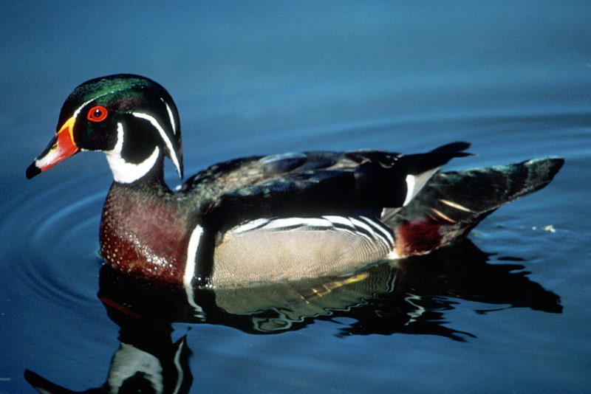 | 3.6667 | 2.0152 | 2 | 24.2424 | 14.0 | 54.9587
 | 8.7 | 6.0375 | 4 | 48.75 | 40.0 | 69.3965
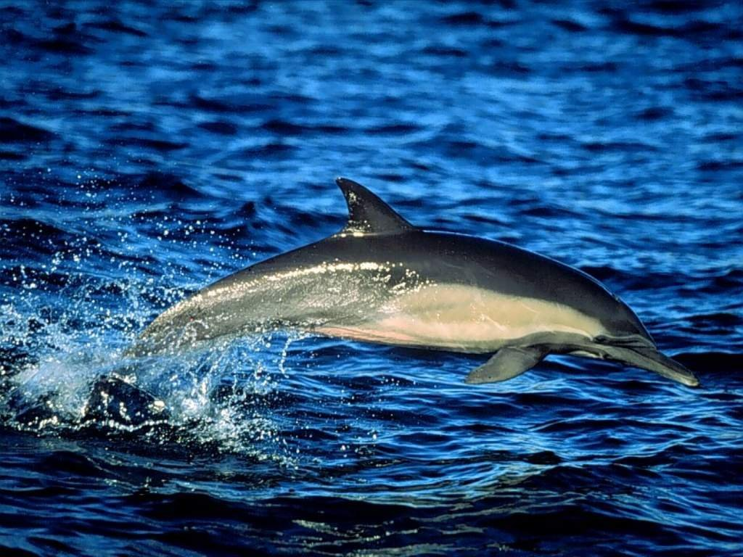 | 1.3067 | 1.3067 | 1 | 8.0 | 28.0 | 100.0
 | 4.394 | 1.9393 | 3 | 34.8485 | 11.0 | 44.1379
 | 11.1867 | 11.1867 | 1 | 38.6667 | 99.0 | 100.0
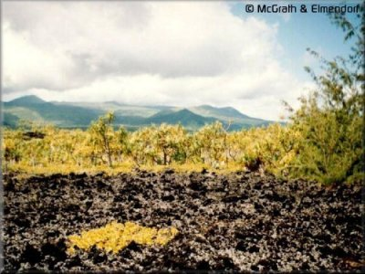 | 11.96 | 8.87 | 4 | 38.0 | 78.0 | 74.16
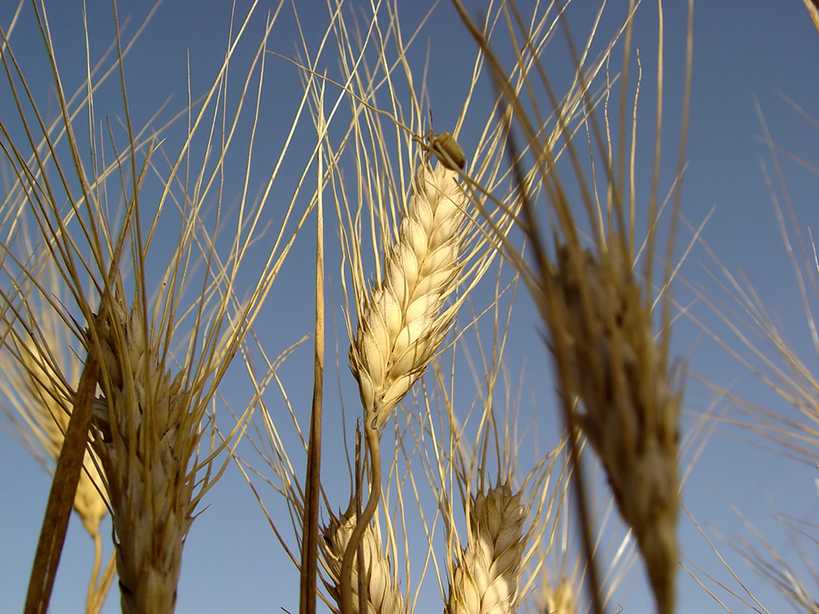 | 9.6933 | 5.1333 | 2 | 73.3333 | 22.0 | 52.9574
 | 21.5875 | 21.5875 | 1 | 87.5 | 52.0 | 100.0
 | 21.08 | 10.5866 | 4 | 56.0 | 61.0 | 50.2214
 | 21.92 | 7.0267 | 9 | 56.0 | 28.0 | 32.0559

